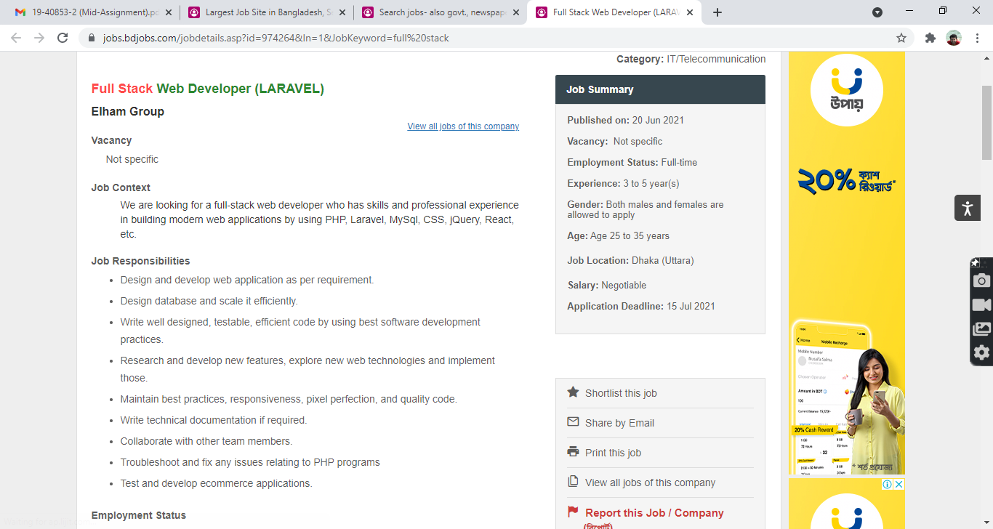

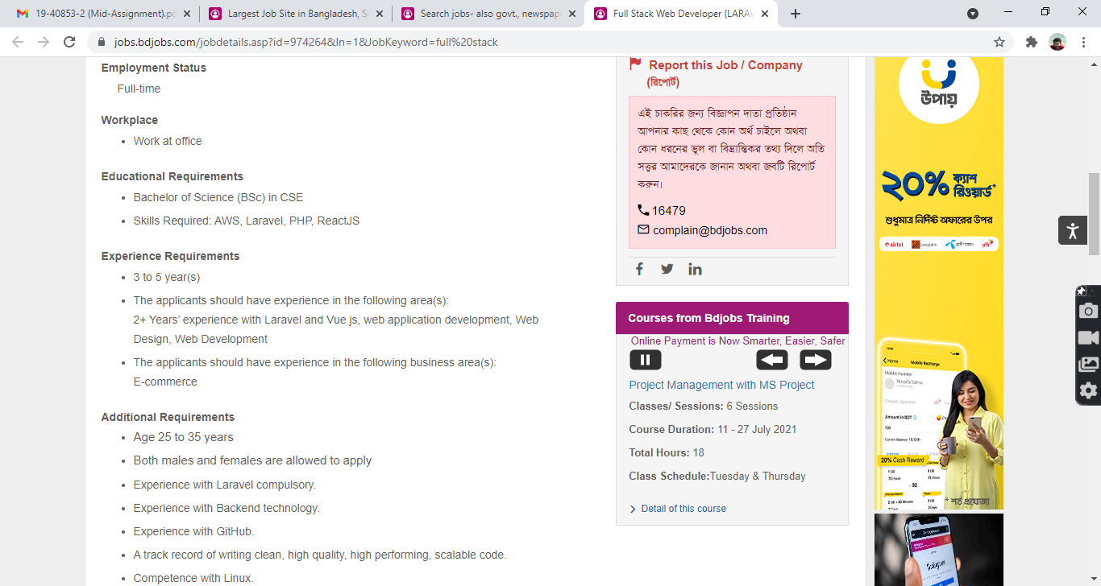

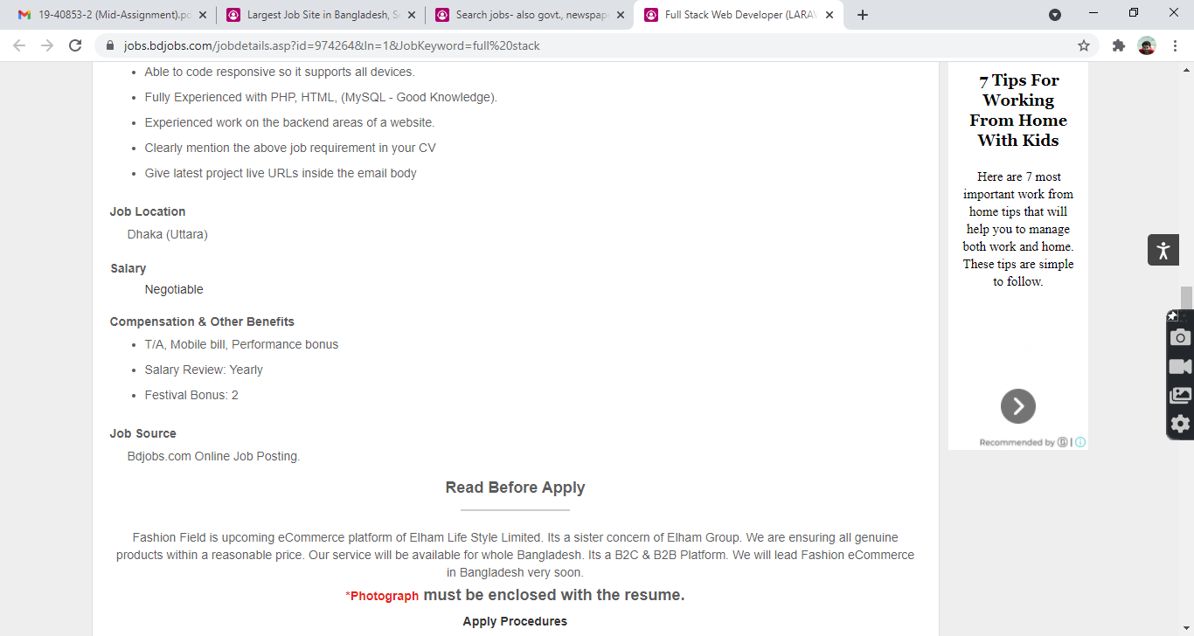

**COVER LETTER WORKSHEET**

**Preparation**

1. Based on the job announcement key words and what you know about the job, what is the company looking for in a candidate? (What are they buying? What problem are they trying to solve? What experience, results, skills, approach, and abilities do they need?)

* skills
* experience
* Dedication to hard work

2. To whom are you sending the letter?

### Name: Technext Limited

Title: Full-stack developers

#### Company, Address: **Dhaka, Sylhet.**

**Opening Paragraph**

1. What is the exact title of the job? __full stack developers____________

2. How did you discover the job was available? (e.g., job board, internet, placement center, professional

meeting, referral, person in hiring firm, career fair, recruiter, etc.) ___Bdjobs.com________

3. Why are you interested in this particular job and company? (e.g., type of work, location, reputation,

opportunities, etc.)

type of work location opportunities

**Middle Paragraph**

1. What do you have that matches those needs? (Experience, education, results, skills, approach, abilities)

* experience
* skills
* abilities

2. Determine the two or three areas that are the highest priority to the company.

* experience
* abilities
* skills

**Closing Paragraph**

1. What is the person expecting you to send? (e.g., resume, letter of interest, salary requirements, references, examples of your work)

resume references

2. What do you want to happen after you send the resume? (An interview, a phone call, an email, etc.) an interview

**Contact Information**

What is your phone and email?

[ankon95@gmail.com](mailto:ankon95@gmail.com)

COVER LETTER FORMAT

**Date :13/6/2021**

**To the concerned**

**Full-stack web developers.**

**Elham Group.**

**Dhaka(Uttara).**

**Dear sir**

**I am writing to apply for your Elham Group Company for Full-stack web developers.I have 2 year experience on Full stack development.**

**As you know that i have some achievement and i have done a few project.And my three article was published on international journal. am also skilled in Laravel,React and JS application.I have also done a cyver security.**

**I am also managing and integrating web APIs.And develop UI from the sketch as per business requirement.I have ability to work under pressure.**

**I have enclosed my resume and hope we can arrange a time to speak.Thank you for your time and consideration.**

**Sincerely,**

**Ankon Sarker.**